

|  |
| --- |
|  |
| LUXURY STAY Hospitality |
| DOCUMENTATION |

SIR ALI IMRAN HUSSAIN | MISS SANA YOUSUF

|  |  |  |  |  |  |  |  |  |  |  |
| --- | --- | --- | --- | --- | --- | --- | --- | --- | --- | --- |
| |  |  | | --- | --- | | Enrollment ID | Student Name | | Student1346661 | YAHYA AHMED MUGHAL | | Student1365428 | AZHAR SHAH | | Student1370719 | CHRIS RIAZ | | Student1365416 | ABDUL MUGHNI SIDDIQUI | |
| SIR ALI IMRAN HUSSAIN | MISS SANA YOUSUF | |



|  |  |
| --- | --- |
|  | Decorative |
| BACKGROUND |
| Luxury Stay Hospitality, a high-end hotel chain known for its exceptional service and luxurious accommodations. With a network of hotels in various locations, Luxury Stay aims to revolutionize its operational efficiency by implementing a cutting-edge Hotel Management System (HMS).  Luxury Stay envisions a modern, scalable, and user-friendly Hotel Management System to transform its operations. The system will streamline workflows, enhance guest experiences, and provide insightful data for strategic decision-making. |

|  |  |
| --- | --- |
|  | Decorative |
| WORKDONE |
| Progress  * Successfully implemented all backend APIs (CRUD operations) using Express.js and integrated them into the React.js frontend. * Developed and managed both Admin and Staff panels with seamless user interfaces. * Ensured robust functionality with CRUD validations, including checks for record duplicity, email format validation, and other required information.  Challenges  * Addressed complexities in preventing deletion of records linked to other collections, ensuring data integrity across the database. * Ensured validations and error handling covered edge cases, particularly in dynamic user inputs.  NEXT STEPS  * Perform extensive testing on both panels to identify and resolve any potential bugs or performance issues. * Optimize API integration to enhance speed and responsiveness. * Gather feedback from stakeholders to refine and enhance the application. * Implement booking management functionality in the Staff Panel to streamline parcel handling and user interactions. |



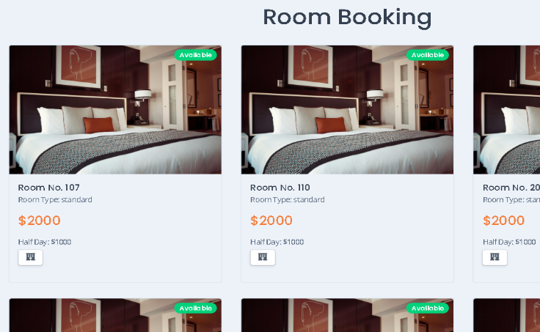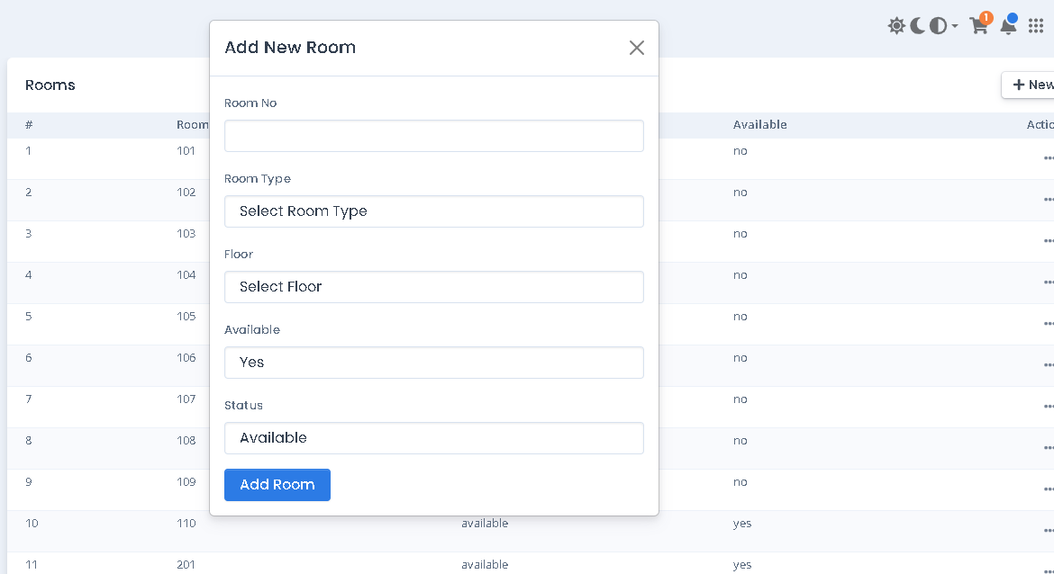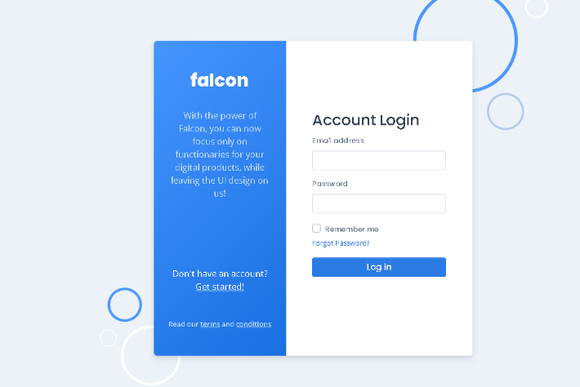

**Room Booking**

**CRUDs**

**Admin/Staff Login**